Copyright for test papers and marking guides remains with *West Australian Test Papers.*

Test papers may only be reproduced within the purchasing school according to the advertised Conditions of Sale.

Test papers should be withdrawn after use and stored securely in the school until Friday, 22nd June 2018.



**SEMESTER ONE**

**MATHEMATICS**

**METHODS**

**UNITS 1**

**2018**

**SOLUTIONS**

***Calculator−free Solutions***

1. (a) (i) 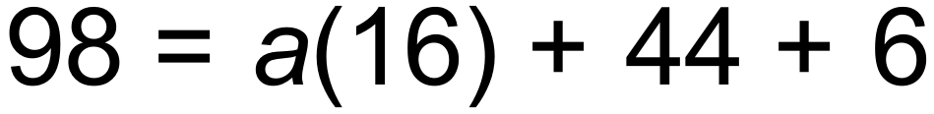

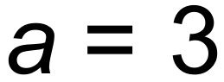 ✓

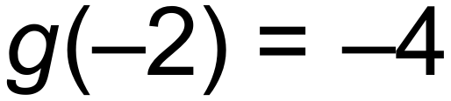 ✓

(ii) 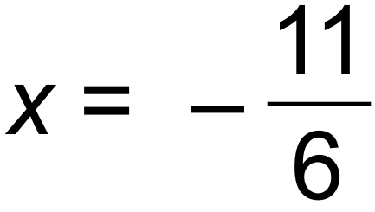 ✓

(iii) Minimum ✓

(b) 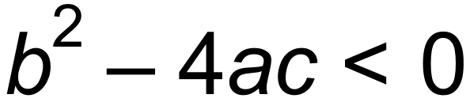

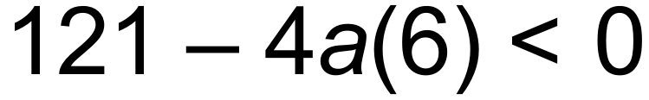 ✓

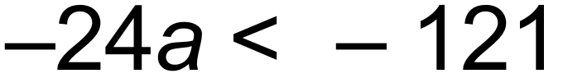

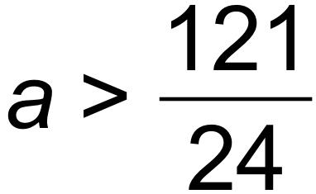 ✓ [6]

2. (a) (i) 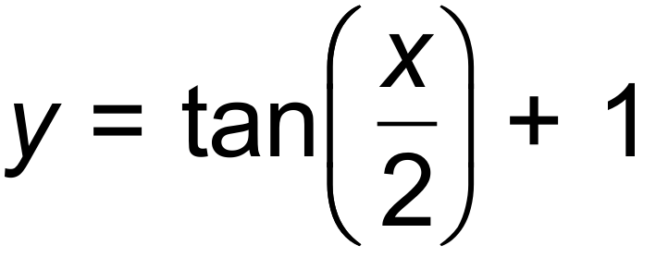 ✓✓

(ii) 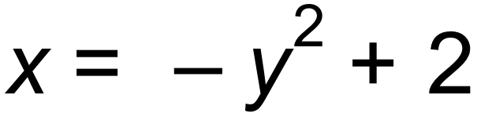 ✓✓

(b)  is a function. For each value of *x* there is only one corresponding *y* value. (If a vertical line is drawn anywhere on this function it will only intersect the graph a maximum of once.) ✓✓ [6]

3. (a) Line *A:* 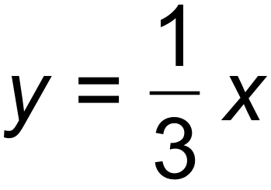

Line *B:* 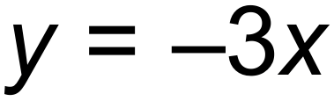 ✓

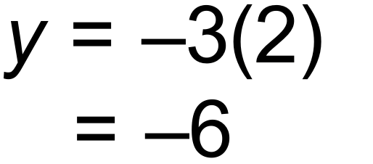 ✓

(b) Line CD: 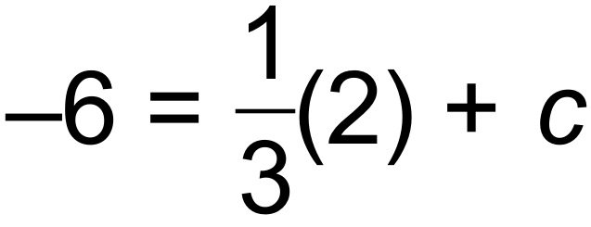

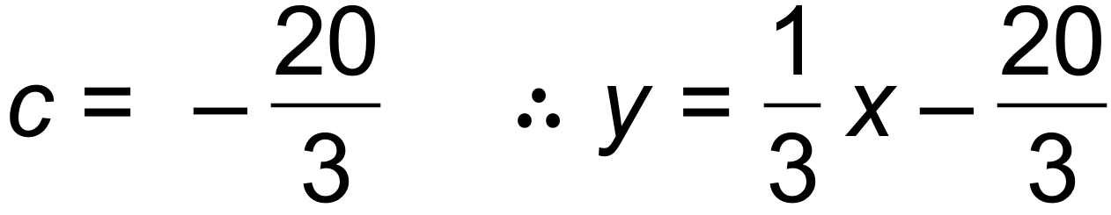 ✓

 ✓

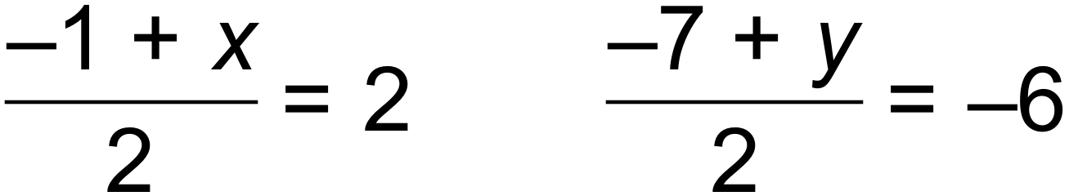 ✓

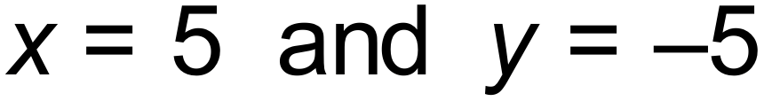

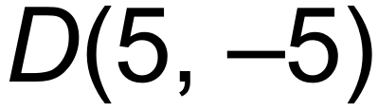 ✓ [6]

4. (a)  ✓

(b)  ✓

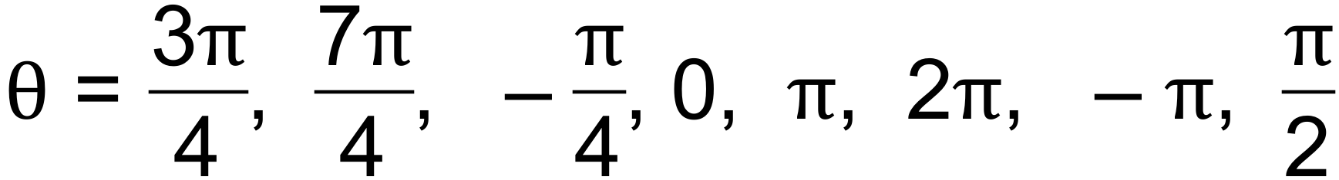 ✓✓ [4]

5. 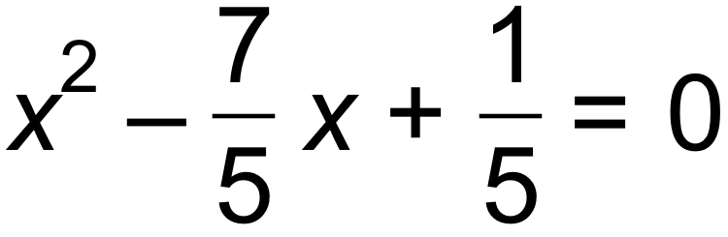

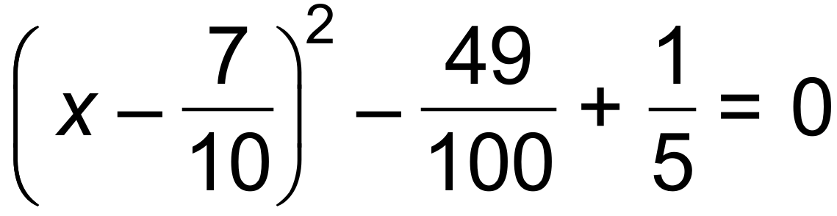 ✓

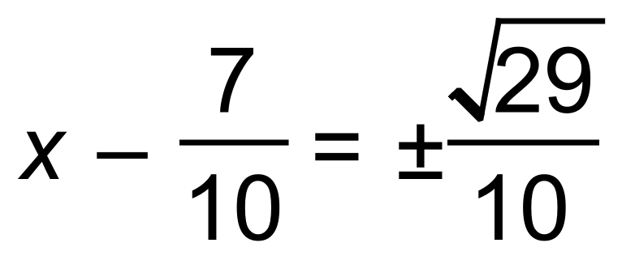 ✓

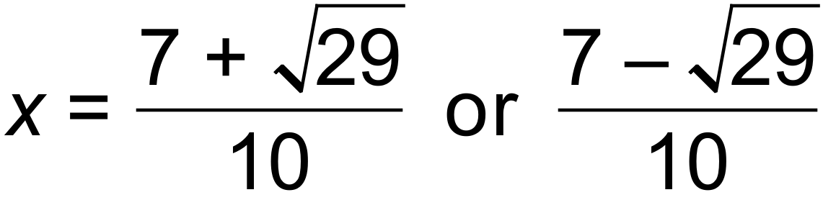 ✓ [3]

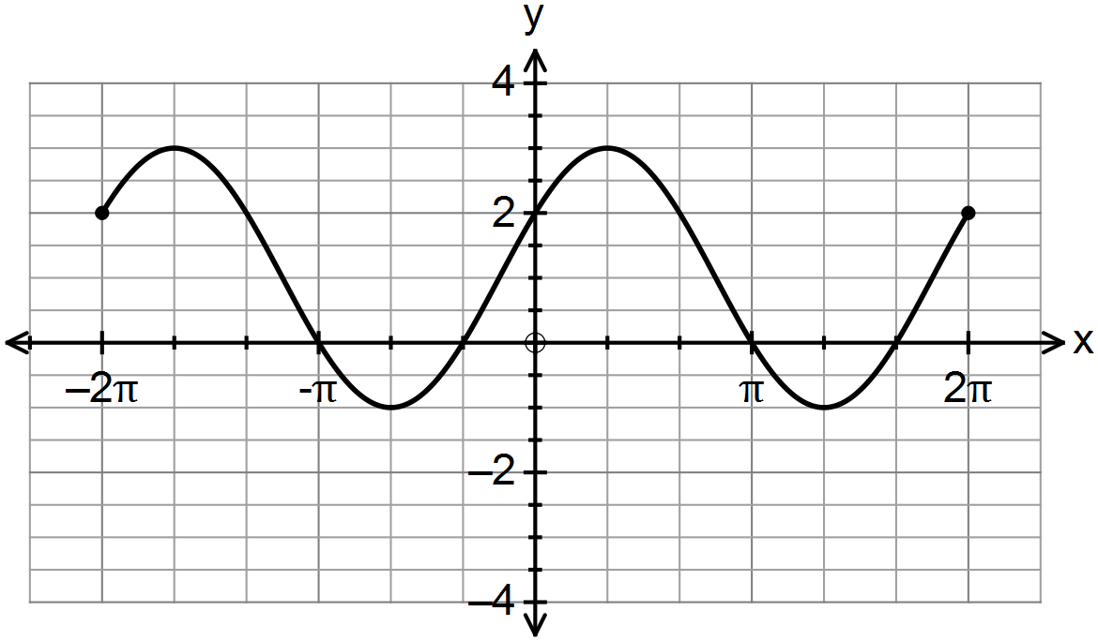6. (a)

✓✓✓

(b) (i) 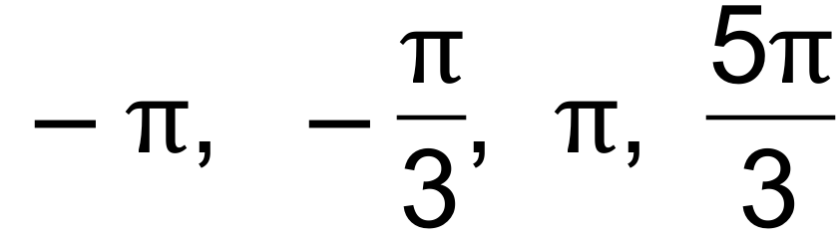 ✓✓

(ii) 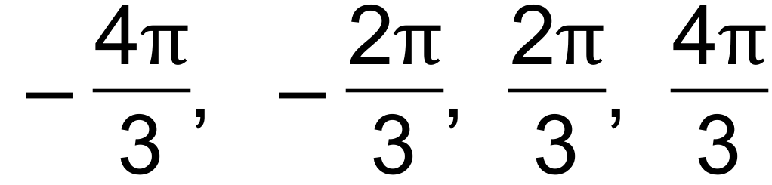 ✓✓ [7]

7. (a) 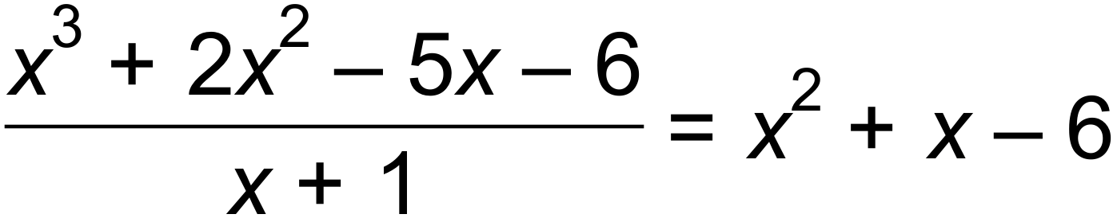 ✓

 ✓✓

(b) (i) 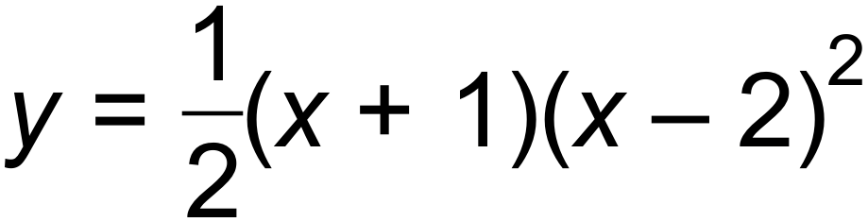 ✓✓

(ii) Vertical dilation, factor . ✓

Horizontal translation one unit to the right ✓

Horizontal dilation, factor . ✓

(ii) 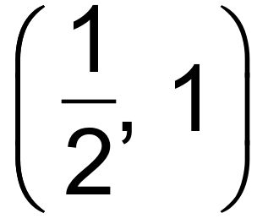 ✓

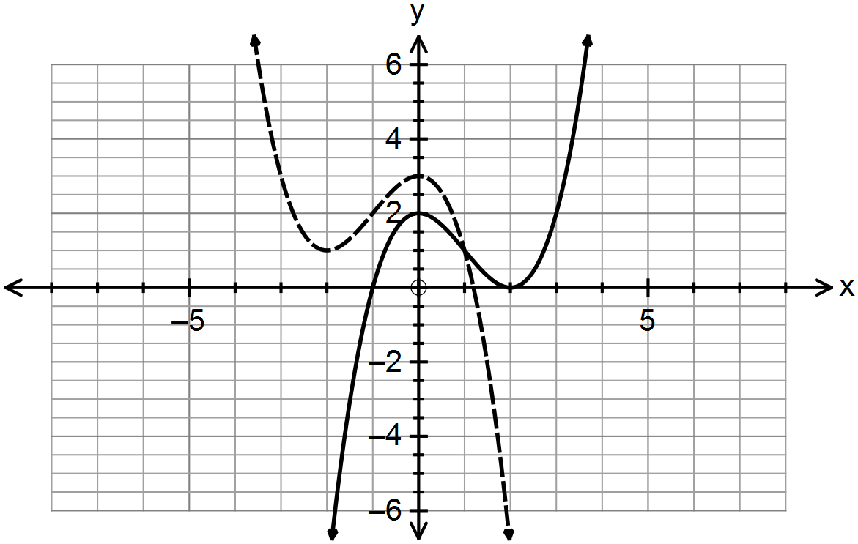 (iii)

✓✓ [11]

|  |  |  |  |  |  |  |  |
| --- | --- | --- | --- | --- | --- | --- | --- |
| 5 | 1 | 5 | 10 | 10 | 5 | 1 |  |
| 6 | 1 | 6 | 15 | 20 | 15 | 6 | 1 |

8. (a) (i)

✓✓

(ii)  ✓✓

(b)  ✓✓ [6]

9. 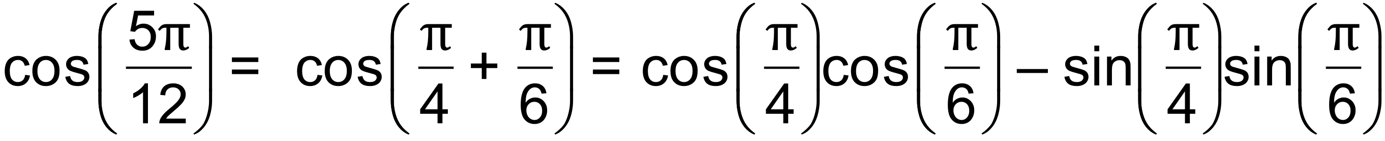 ✓

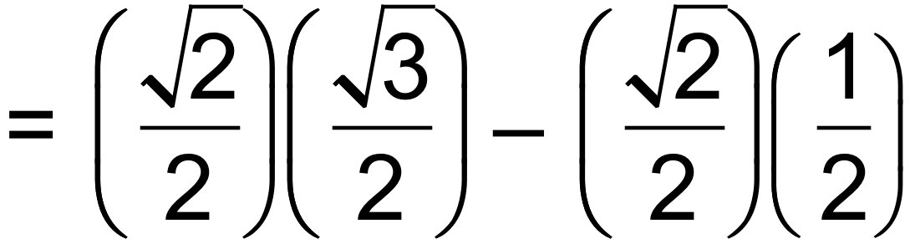 ✓

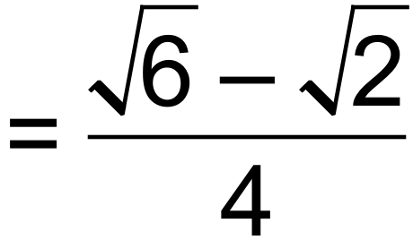 ✓ [3]

***Calculator−assumed Solutions***

10. (a)  ✓

(b) *R* = 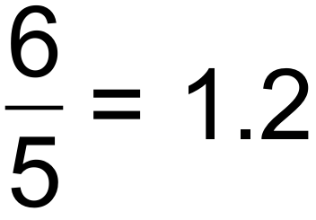 ohms ✓

(c) 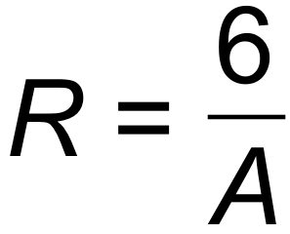

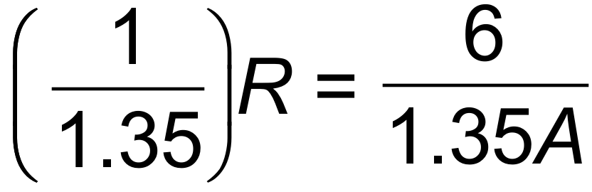 ✓

R will decrease by 74% ✓

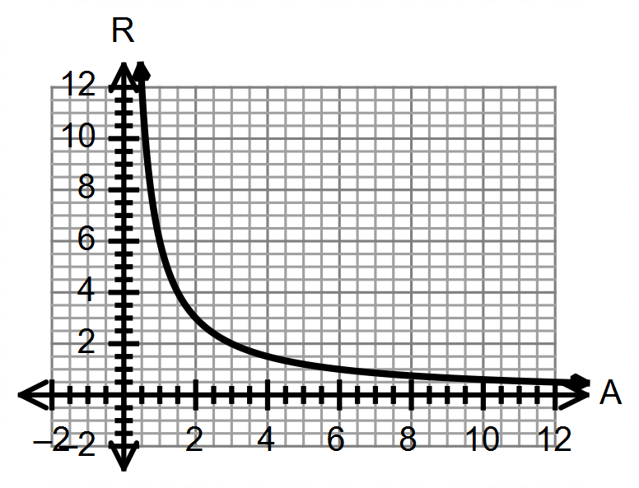(d)

✓✓✓ [7]

11. (a)

|  |  |  |  |  |  |
| --- | --- | --- | --- | --- | --- |
|  |  | Number of toilets | | |  |
|  |  | **1** | **2** | **3 or more** | **Total** |
| Number of  bedrooms | **1** | 35 | **0** | **0** | 35 |
| **2** | **50** | 5 | 0 | 55 |
| **3** | 5 | 65 | **15** | **85** |
| **4 or more** | 0 | 0 | **25** | 25 |
| **Total** |  | **90** | **70** | **40** | **200** |

✓✓

(b) (i) 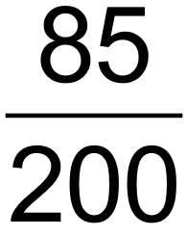 ✓

(ii) 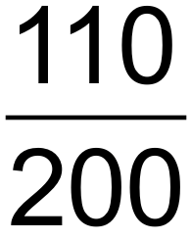 ✓

(iii) 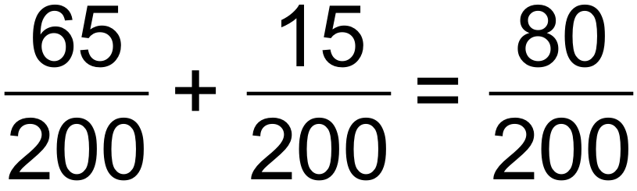 ✓✓

(iv) 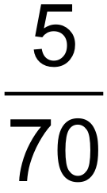 ✓✓

(c) 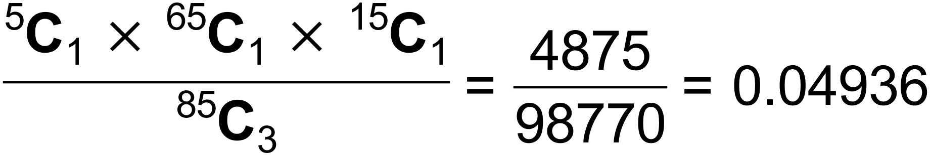 ✓✓ [10]

12. (a) 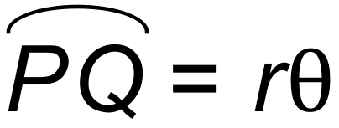

 ✓✓

(b)  ✓

(c) Area of sector = 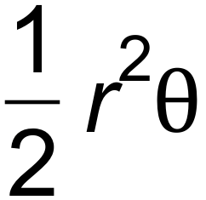

= 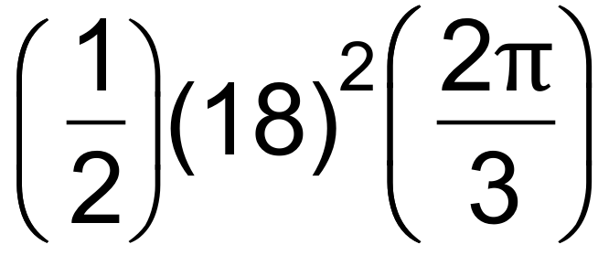

= 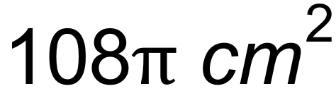 ✓

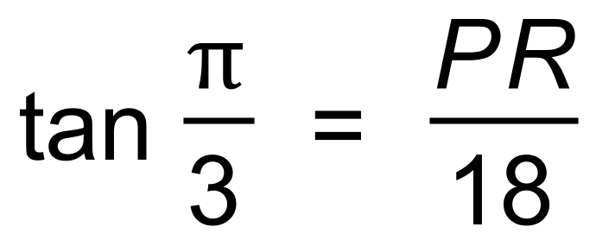 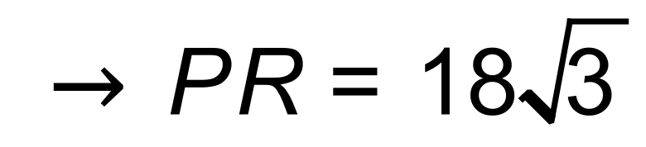 ✓

Area of kite = 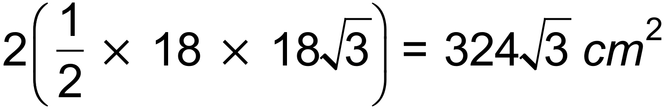 ✓

Area of shaded area = 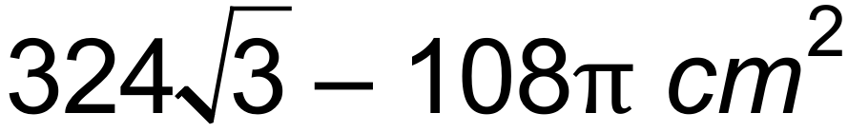 ✓ [7]

13. (a) 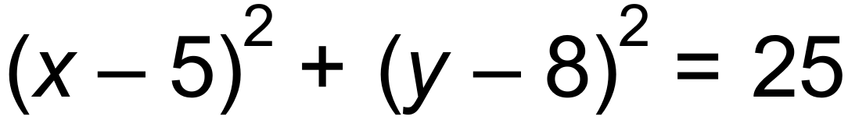 ✓

 ✓

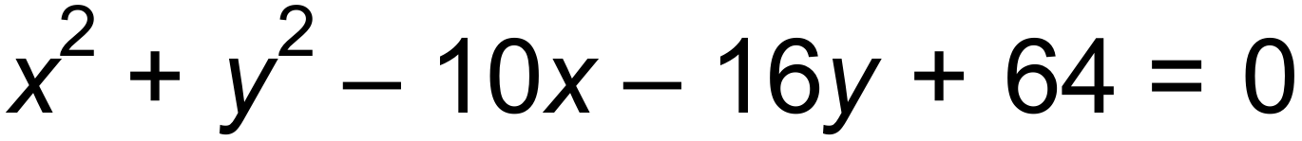

(b) (i) M(2, 4) N(8, 4) ✓

MN = 6 units ✓

(ii) 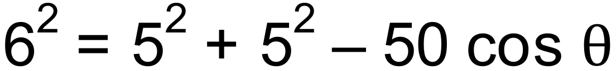

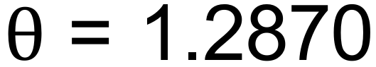 ✓

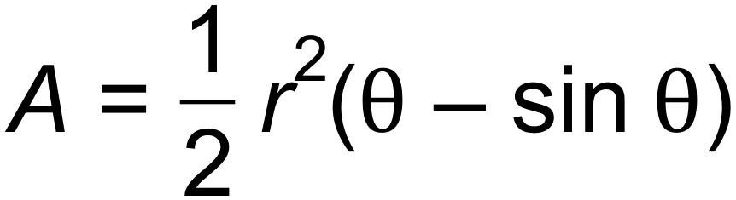

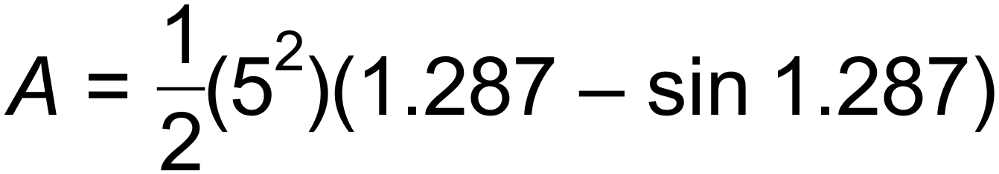 ✓

 units2 ✓ [7]

14. (a) (i)  ✓

(ii) 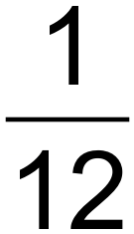 ✓

(iii) 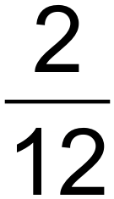 ✓

(b) 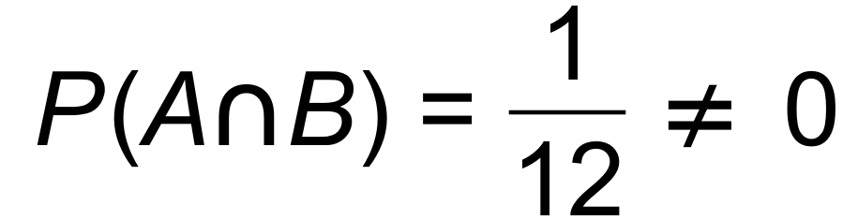 ✓

(c) (i)  ✓

(ii)  ✓

(iii) 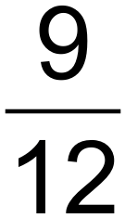 ✓ [7]

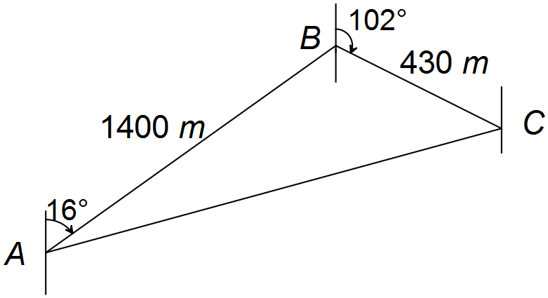

15. (a)

 ✓

 ✓

 ✓

(b) 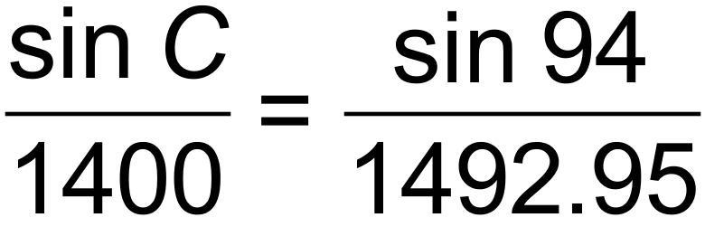 ✓

 ✓

 or 

Bearing is 212.7°T ✓ [6]

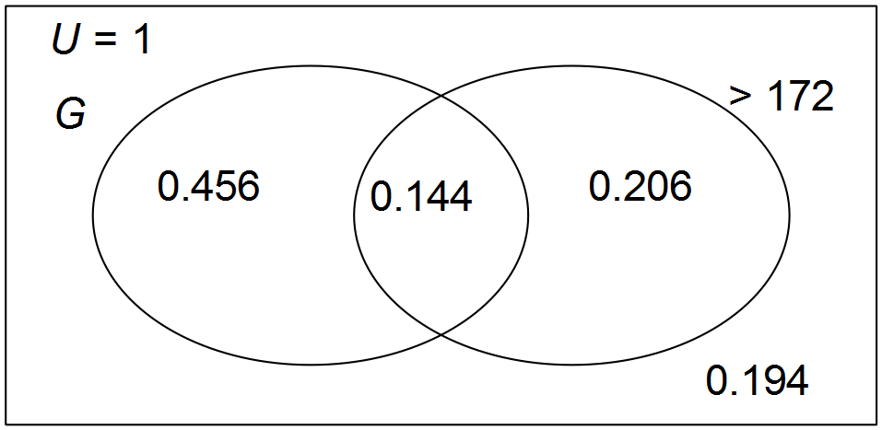16. (a) 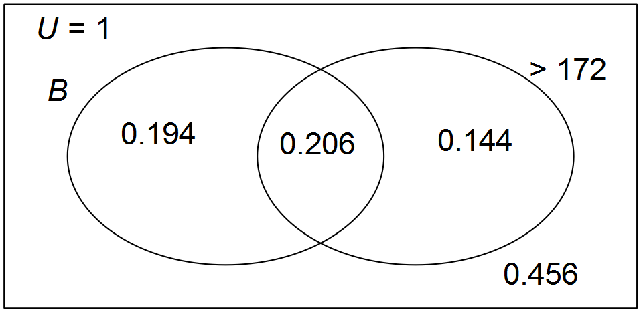

✓✓✓

(b) (i) 0.144 ✓

(ii) 0.194 ✓

(iii) 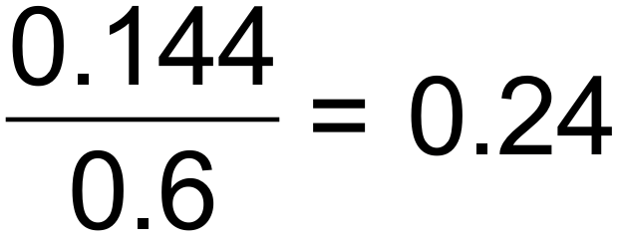 ✓✓

(c) Girls over 172 cm = 38 ✓

Boys over 172 cm = 55 ✓

38:55 = 1:1.45 ✓ [10]

17. (a) 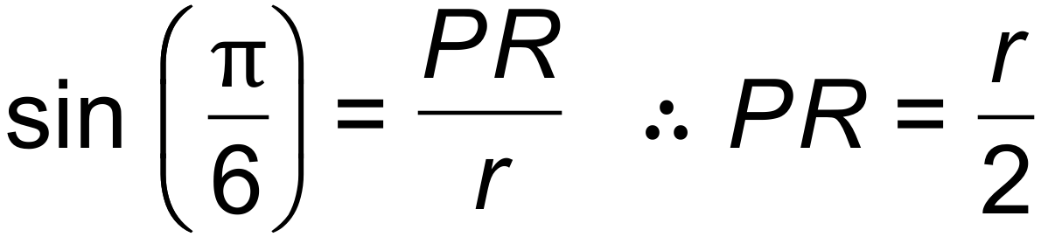 ✓

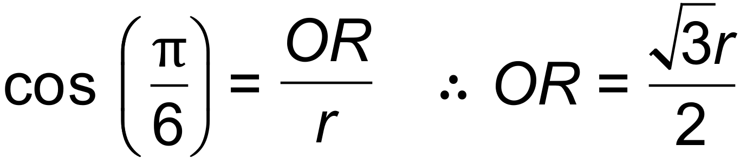 ✓

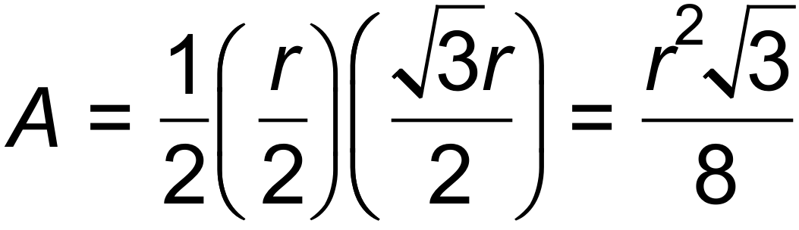 ✓

(b) 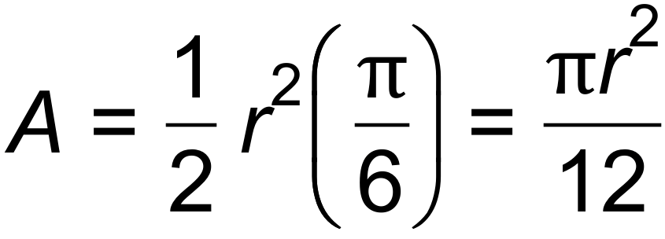 ✓

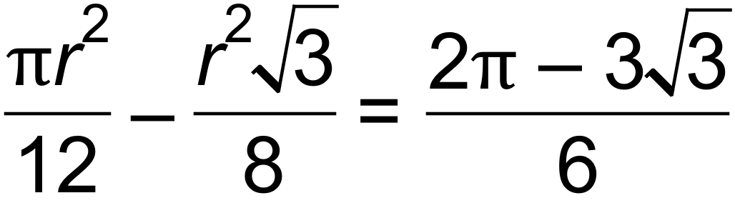 ✓

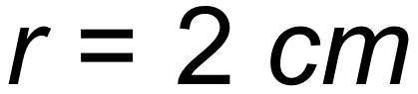 ✓ [6]

18. (a) (i) 15! = 1 307 674 368 000 ✓

(ii) 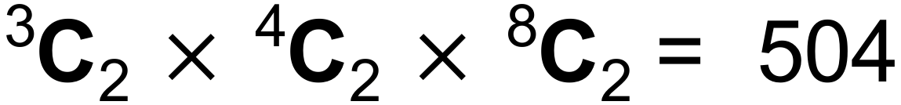 ✓✓

(iii) 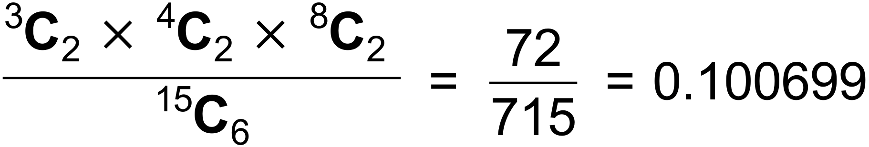 ✓✓

(b) (i)

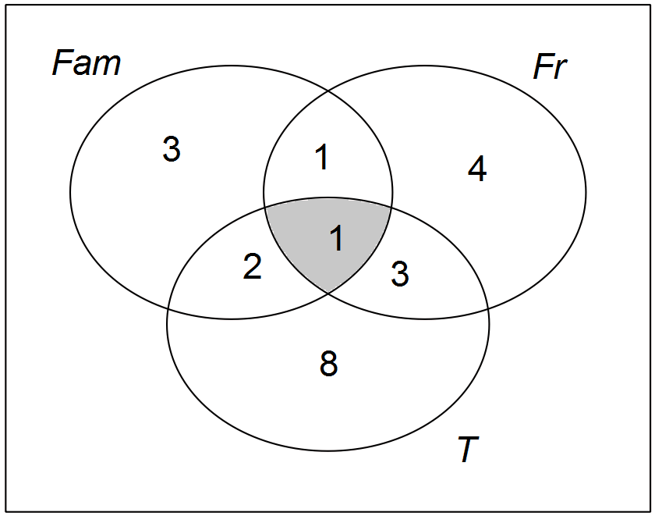

✓

This image has family and friends and travel in it. ✓

(ii) 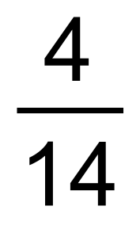 ✓✓ [9]

19. (a) D H ✓

(b) C G ✓

(c) G ✓

(d) G ✓

(e) H ✓

(f) A ✓

(g) E ✓

(h) A B ✓ [8]

20. (a)  ✓

 ✓

(b) 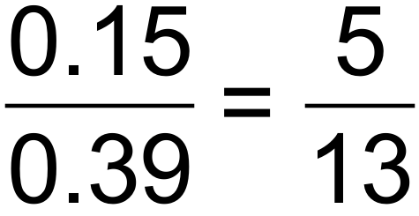 ✓✓

(c) The events are not independent. ✓

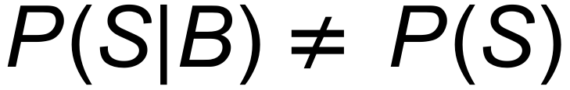

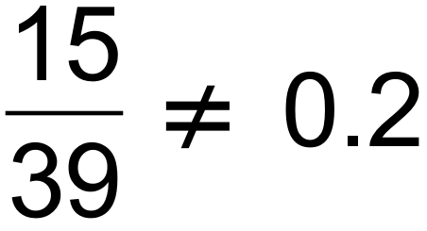 ✓ [6]

21. (a) (i) V= 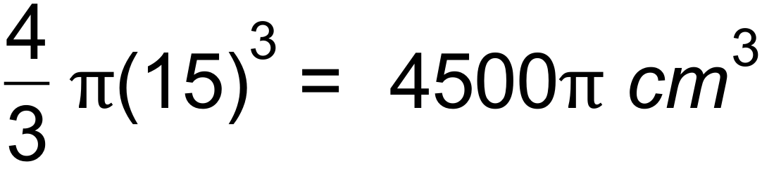 ✓

(ii) 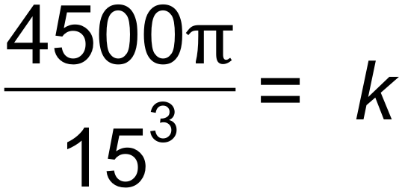 ✓

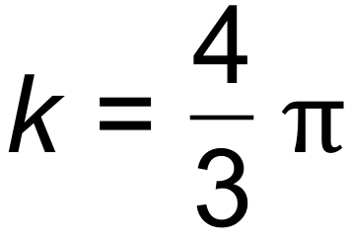

(iii) 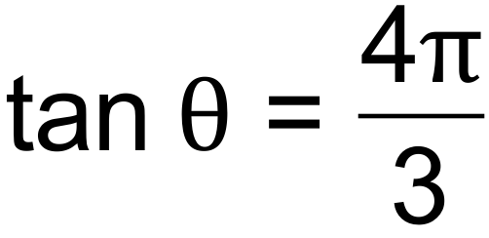 ✓

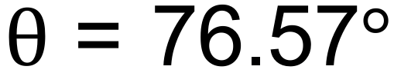 ✓

(b) Let *x* be the length, then  is the width

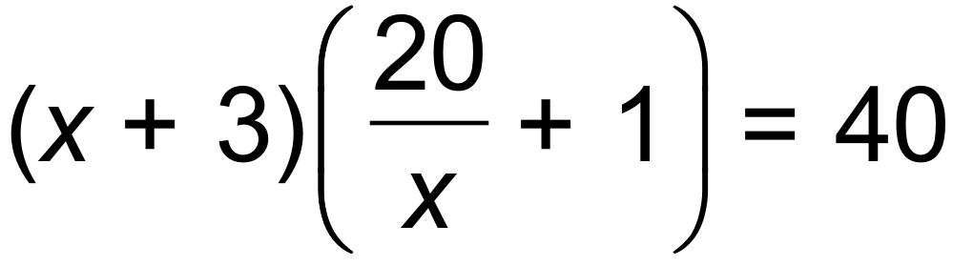 ✓

 ✓

Original dimensions are 4*m* x 5*m* or 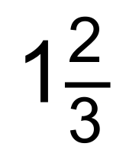*m* x 12*m* ✓

(c) Domain:  ✓

Range: 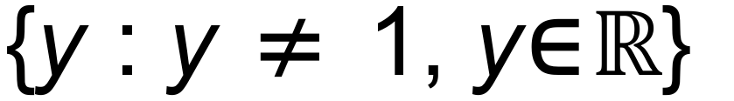 ✓ [9]

22. A: 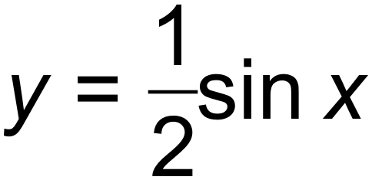 B: 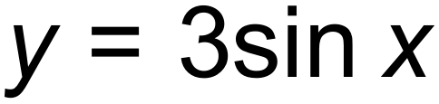 ✓✓

The amplitude for a quieter sound is .

The amplitude increases to 3 to produce a louder sound. ✓

C: 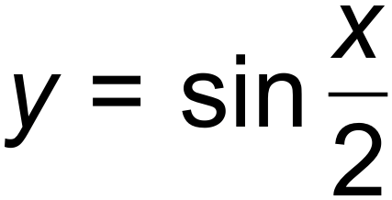 D: 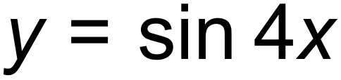 ✓✓

The period for a deeper pitch is 

The period for a higher pitch is . ✓ [6]